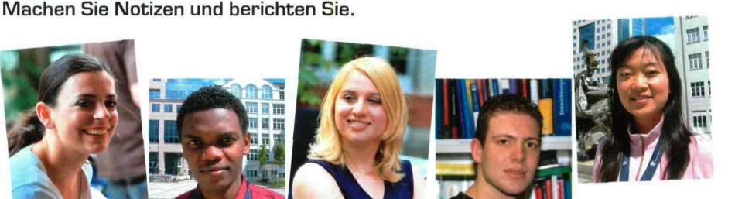

|  |  |  |  |
| --- | --- | --- | --- |
| Name | Woher? | Alter | studiert |
| Andrick |  |  |  |
| Jystiana |  |  |  |
| Matthias |  |  |  |
| Da |  | ? | Auslandsgermanistik |
|  |  |  |  |

Ergänze die fehlenden Informationen.

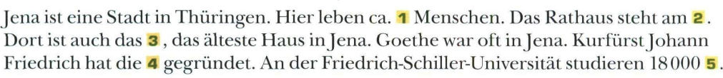

1, _______________; 2, _______________; 3, _______________; 4, _______________

5, _______________

